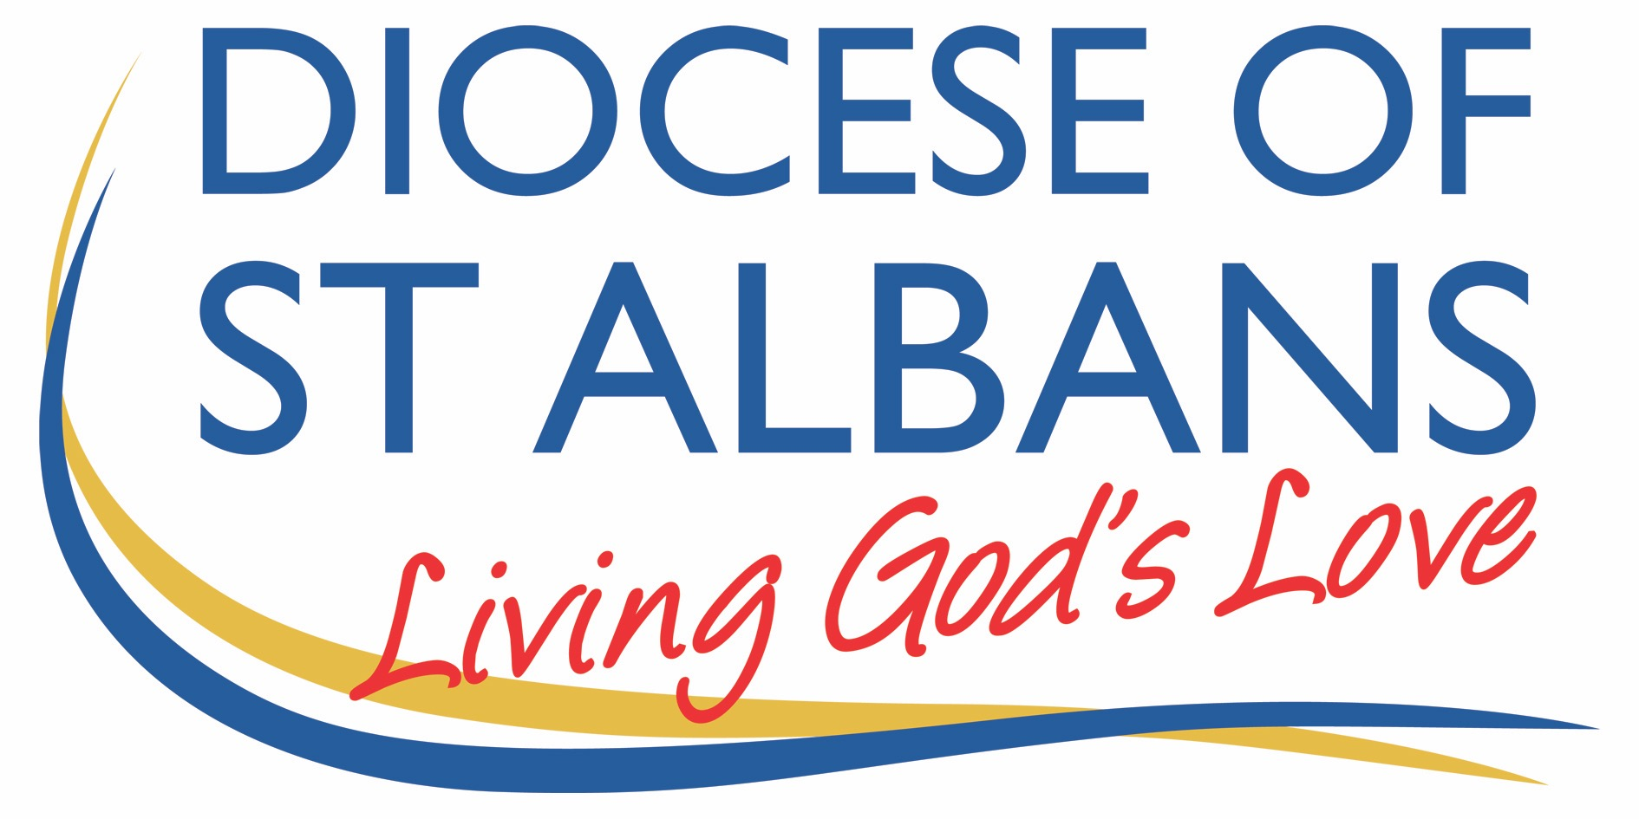
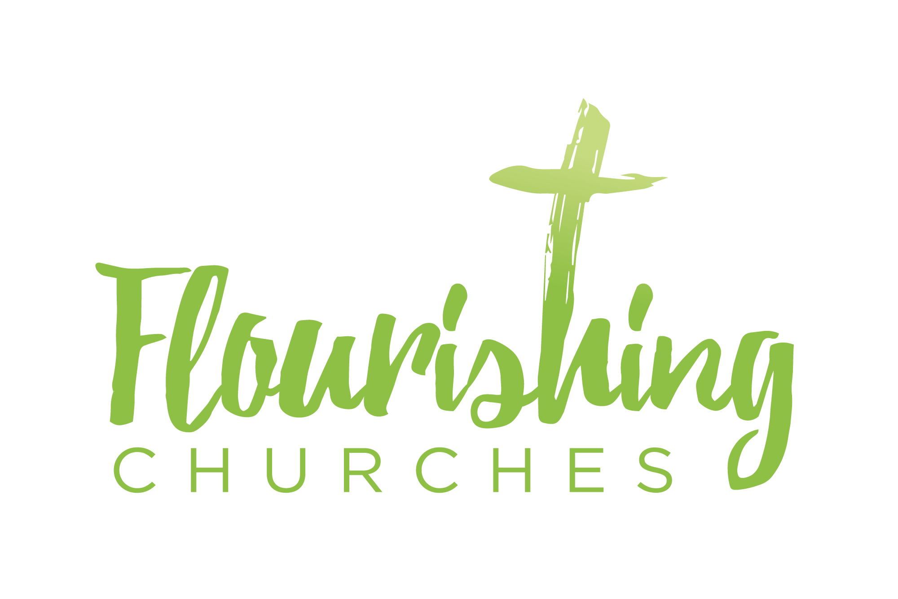

Sunday 17th January – Epiphany 2
John 1 v43-end

Welcome to Praying Together but Separately

welcome and introduction

hymn. Alleluia! sing to Jesus. sung by St Martin’s Voices

- Alleluia, sing the Jesus!
His the sceptre, his the throne;
alleluia, his the triumph,
his the victory alone:
hark, the songs of peaceful Sion
thunder like a mighty flood;
Jesus out of every nation
hath redeemed us by his blood.

- Alleluia, not as orphans
are we left in sorrow now;
alleluia, he is near us,
faith believes, nor questions how:
though the cloud from sight received him,
when the forty days were o’er,
shall our hearts forget his promised,
‘I am with you evermore’?

- Alleluia, bread of angels,
thou on earth out food, our stay;
alleluia, here the sinful
flee to thee from day to day:
Intercessor, Friend of sinners,
earth’s Redeemer, plead for me,
where the songs of all the sinless
sweep across the crystal sea.

- Alleluia, King eternal,
thee the Lord of lords we own;
alleluia, born of May,
earth thy footstool, heaven thy throne,
thou within the veil hast entered,
robed in flesh, our great High Priest:
thou on earth both Priest and Victim
in the eucharistic feast.
William Chatterton Dix (1837-1898)

gathering prayer

Psalm 139 (on reading sheet)

confession and absolution

kyrie confession
God be gracious to us and bless us,
And make your face shine upon us:
Lord have mercy. Lord have mercy

May your ways be known on the earth,
Your saving power among the nations:
Christ, have mercy. Christ, have mercy.

You, Lord, have made known your salvation,
And reveal your justice in the sight of the nations:
Lord have mercy. Lord have mercy

Invitation to confession for Epiphany season:
The grace of God has dawned upon the world through our Saviour Jesus Christ, who sacrificed himself for us to purify a people as his own. Let us confess our sins. Cf Titus 2.11-14

Almighty God, our heavenly Father, we have sinned against you, thought our own fault, in thought and word and deed, and in what we have left undone.
We are heartily sorry and repent of all our sins.
For your Son our Lord Jesus Christ’s sake, forgive us all that is past; and grant that we may serve you in newness of life to the glory of your name. Amen

absolution: The Lord enrich you with his grace,
and nourish you with his blessing;
the Lord defend you in trouble and keep you from all evil;
The Lord accept your prayers,
And absolve you from your offences,
For the sake of Jesus Christ, our Saviour. Amen

affirmation of faith
Do you believe and trust in God the Father, source of all being and life, the one for whom we exist?
We believe and trust in Him

Do you believe and trust in God the Son, who took our human nature, died for us and rose again?
We believe and trust in Him.

Do you believe and trust in God the Holy Spirit, who gives life to the people of God and makes Christ known in the world?
We believe and trust in Him

This is the faith of the Church.
This is our faith.
We believe and trust in one God,
Father, Son and Holy Spirit. Amen

prayer of the Day:
Almighty God,
in Christ you make all things new:
transform the poverty of our nature by the riches of your grace,
and in the renewal of our lives
make known your heavenly glory;
through Jesus Christ your Son our Lord,
who is alive and reigns with you,
in the unity of the Holy Spirit,
one God, now and for ever. Amen.

Reflection
Breathe slowly and deeply.
Ask God to speak to you through the passages that we are about to read.

Bible Readings: Old Testament
1 samuel 3:1-10 (on Reading sheet)

hymn: Christ is the one who calls
sung by St Martin’s Voices

1 Christ is the one who calls,
the one who loved and came,
to whom by right it falls
to bear the highest Name:
and still today
our hearts are stirred
to hear his word
and walk his way.

2 Christ is the one who seeks,
to whom our souls are known.
The word of love he speaks
can wake a heart of stone;
for at that sound
the blind can see,
the slave is free,
the lost are found.

3 Christ is the one who died,
forsaken and betrayed;
who, mocked and crucified,
the price of pardon paid.
Our dying Lord,
what grief and loss,
what bitter cross,
our souls restored!

4 Christ is the one who rose
in glory from the grave,
to share his life with those
whom once he died to save.
He drew death's sting
and broke its chains,
who lives and reigns,
our risen King.

5 Christ is the one who sends,
his story to declare;
who calls his servants friends
and gives them news to share.
His truth proclaim
in all the earth,
his matchless worth
and saving Name.

Timothy Dudley Smith (b.1926)
© Timothy Dudley-Smith in Europe and Africa. Reproduced by permission of Oxford University Press. All rights reserved.
the gospel
Alleluia, Alleluia.
Christ was revealed in flesh, proclaimed among the nations and believed in throughout the world. Alleluia.

Hear the Gospel of our Lord Jesus Christ according to John

John 1 v 43-51 Jesus Calls Philip and Nathanael
The next day Jesus decided to go to Galilee. He found Philip and said to him, ‘Follow me.’ Now Philip was from Bethsaida, the city of Andrew and Peter. Philip found Nathanael and said to him, ‘We have found him about whom Moses in the law and also the prophets wrote, Jesus son of Joseph from Nazareth.’ Nathanael said to him, ‘Can anything good come out of Nazareth?’ Philip said to him, ‘Come and see.’ When Jesus saw Nathanael coming towards him, he said of him, ‘Here is truly an Israelite in whom there is no deceit!’ Nathanael asked him, ‘Where did you come to know me?’ Jesus answered, ‘I saw you under the fig tree before Philip called you.’ Nathanael replied, ‘Rabbi, you are the Son of God! You are the King of Israel!’ Jesus answered, ‘Do you believe because I told you that I saw you under the fig tree? You will see greater things than these.’ And he said to him, ‘Very truly, I tell you, you will see heaven opened and the angels of God ascending and descending upon the Son of Man.’
Some thoughts for further Reflection:

It perhaps needs no saying that we have all reacted very differently to the pandemic and lockdown 3.0 and news of the new strain and vaccine. Our range of responses and emotions are understandable and there seems no right and wrong way to process what is happening. My risk is not your risk. My needs for wellbeing and good functioning are not yours. Your anxiety and frustrations will be different from mine. So it seems to me that today’s Gospel reading from John is a real gift – a gift that gets us back to our fundamental roots of what it is to be a disciple – as the world chops and changes, ebbs and flows, erupts and calms – we, perhaps more than ever, rely and lean on our core calling and our core identity.

As Christians that is as adopted children of God – precious and unique members of God’s family, created and loved, forgiven and redeemed. Maybe we have been baptised into this glorious family of saints and sinners – maybe we are just thinking about it. Maybe we are waiting for our baptism until our churches can gather again in number and volume.

But knowing that we are created by God and loved by God is our core – and our response to that abundant love and grace is to follow. To follow that ‘Love so amazing, so divine, demands my Soul, my Life, my All’ as the hymn writer Isaac Watts said in his hymn When I survey the Wonderous Cross. And that is what we read of today. Jesus, son of Joseph from Nazareth – the embodiment of God’s love for us and the world. Not an eldest son from some hic town near Galilee – where Nathanael jokes – can anything good come from there! You’ll no doubt have your own local jokes about ‘can anything good from ****** and you name somewhere the wrong side of the tracks.

But this wasn’t some young lad who was helping in his father’s workshop – this was Love. Compelling and astounding love. Love that walked along the shores of Galilee and bid others to follow – and so extraordinary was that love and that grace and that wisdom and that power that people did follow. They did see Jesus and follow him. And Philip told his friend Nathanael – he was so convinced by Jesus he wanted his friend to be convinced too – and not just convinced but transformed and transfigured. And Jesus didn’t disappoint – he saw into Nathanael’s heart and life and let him know that truth. Nathanael was astonished that he was known by the Messiah – he was seen and known.

And that is true of us too – we are seen and heard and known and loved. And we are invited to ‘come, see’. See this Jesus who knows us and loves us. See this Jesus in scripture who heals and saves, teaches and transforms. See.

And what was Nathanael told he would see? ‘I tell you; you will see heaven opened and the angels of God ascending and descending upon the Son of Man’. Jesus is echoing the image found in Genesis 28 where Jacob (having reached rock bottom and was fleeing his own underhand decisions and broken relationship with his brother Esau) had a dream. He laid his head down on a stone and dreamed that he was a ladder reaching up to heaven and on that ladder, there were angels ascending and descending and God himself stood beside him and called him to trust in him. Jacob, despite his messy life, his dishonourable actions and his broken relationships was called by God, was ministered to by God. And God met Philip and Nathanael too – and they recognised him and followed.

And God meets us too – as Rowan Williams once said (and I’m paraphrasing) – the problem in prayer isn’t God not showing up, it’s me not showing up. He was referring to that ‘seeing of God’ that prayer allows and that being seen. God does this anyway – God calls, and sometimes we need to get up and follow him, fully ourselves and fully present, not distracted and emotionally absent.

That is the gift of today – we can be fully ourselves with God and we are met with God’s complete love. And through that love we dare to follow – unsure of the days ahead but knowing however messy it gets (just like it did for Jacob) God sees us, hears, us, calls us and loves us. I hope you find as much strength and courage and comfort in that as I do.
Rev Kate Peacock

SILENCE During this time of quiet invite Jesus into your hearts.
God of love
hear our prayer.
Father of all
hear your children’s prayer.
In faith we pray
we pray to you our God.
Lord, meet us in the silence
and hear our prayer.

hymn: Will you come and follow me
sung by St Martin’s Voices

1 Will you come and follow me
if I but call your name?
Will you go where you don't know
and never be the same?
Will you let my love be shown,
will you let my name be known,
will you let my life be grown,
in you and you in me?
2 Will you leave yourself behind
if I but call your name?
Will you care for cruel and kind
and never be the same?
Will you risk the hostile stare
should your life attract or scare?
Will you let me answer prayer
in you and you in me?
3 Will you let the blinded see
if I but call your name?
Will you set the prisoners free
and never be the same?
Will you kiss the leper clean,
and do such as this unseen,
and admit to what I mean
in you and you in me?
4 Will you love the 'you' you hide
if I but call your name?
Will you quell the fear inside
and never be the same?
Will you use the faith you've found
to reshape the world around,
through my sight and touch and sound
in you and you in me?
5 Lord, your summons echoes true
when you but call my name.
Let me turn and follow you
and never be the same.
In your company I'll go
where your love and footsteps show.
Thus I'll move and live and grow
in you and you in me.
John L Bell (born 1949) and Graham Maule (1958-2019)
© 1987 WGRG, c/o Iona Community, 21 Carlton Court, Glasgow, G5 9JP, Scotland. www.wildgoose.scot
our prayers
In the power of the Spirit and in union with Christ, let us pray to the Father.
For the peace of the whole world, for the welfare of the Holy Church of God,
and for the unity of all, let us pray to the Lord.
Lord, have mercy.
For Alan, Michael and Richard our bishops, for the leaders of our sister Churches,
and for all clergy and people, let us pray to the Lord.
Lord, have mercy.
For Elizabeth our Queen, for the leaders of the nations, and for all in authority, let us pray to the Lord.
Lord, have mercy.
For this community, in which I live for every city, town and village, and for all the people who live within them, let us pray to the Lord.
Lord, have mercy.
For the sick and the suffering, for the NHS and key workers, for families who watch and wait and for all who are anxious, let us pray to the Lord.
Lord, have mercy.
Remembering all who have gone before us in faith, and in communion with all the saints,
we commit ourselves, one another,
and our whole life to Christ our God; to you, O Lord.

a prayer concerning the Coronavirus
God of compassion,
be close to those who are ill, afraid or in isolation.
in their loneliness, be their consolation;
in their anxiety, be their hope;
in their darkness, be their light;
through him who suffered alone on the cross,
but reigns with you in glory,
Jesus Christ our Lord.
Amen.

Musical introduction by Nicholas

An act of spiritual Communion
My Jesus,
I believe that You
are present in the Most Holy Sacrament.
I love You above all things,
and I desire to receive You into my soul.
Since I cannot at this moment
receive You sacramentally,
come at least spiritually into my heart.
I embrace You as if You were already there and unite myself wholly to You.
Never permit me to be separated from You. Amen.

The Lord’s Prayer
Our Father, who art in heaven, hallowed be thy name;
thy kingdom come; thy will be done;
on earth as it is in heaven.
Give us this day our daily bread.
And forgive us our trespasses,
as we forgive those who trespass against us.
And lead us not into temptation; but deliver us from evil.
For thine is the kingdom,
the power and the glory, for ever and ever. Amen.

the peace Christ is our peace. If anyone is in Christ, there is a new creation. The old has passed away: behold, everything has become new. 2 Corinthians 5:17

the final hymn. I come with joy, a child of God
sung by St Martin’s Voices
1 I come with joy, a child of God,
forgiven, loved and free,
the life of Jesus to recall,
in love laid down for me.
2 I come with Christians far and near
to find, as all are fed,
the new community of love
in Christ's communion bread.
3 As Christ breaks bread, and bids us share,
each proud division ends.
The love that made us, makes us one,
and strangers now are friends.
4 The Spirit of the risen Christ,
unseen, but ever near,
is in such friendship better known,
alive among us here.
5 Together met, together bound
by all that God has done,
we'll go with joy, to give the world
the love that makes us one.
Brian Wren (b.1936)
© 1971, 1995 Stainer & Bell Ltd

the blessing
Christ the Son of God perfect in you the image of his glory and gladden your hearts with the good news of his kingdom;
and the blessing of God the Father,
God the Son and God the Holy Spirit
be with you, and those you love, today and for evermore. Amen

To keep up to date with resources and dates from the Flourishing Churches team, please follow us on Facebook: https://www.facebook.com/Flourishing-Churches-St-Albans-Diocese-105528844479183
Also St Albans Diocese Youth Service: https://www.facebook.com/stalbansdys/
And Children’s Ministry St Albans Diocese: https://www.facebook.com/stalbanscme

